Parents Rank One Instructions
1. Go to https://rankonesport.com/ on mobile browser
2. Click on “Parents Click Here” Red Button.

3. Click on “Online Forms – Go To Forms” Button
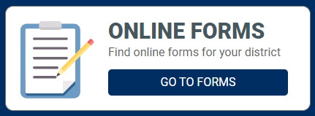
4. Select your State – Click on Kansas
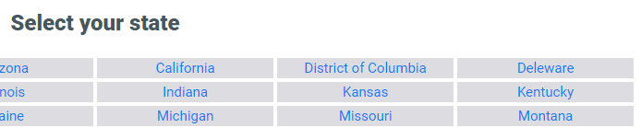
5. Select your district – Wichita Public Schools
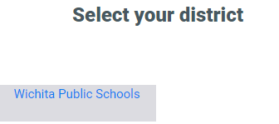
6. Welcome to Parent Portal (Read the Directions) – Click on Click Here or Proceed to Online Forms.
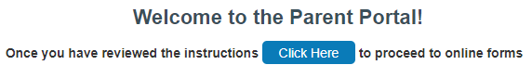
7. Log In (You will need to create a log in at this point).
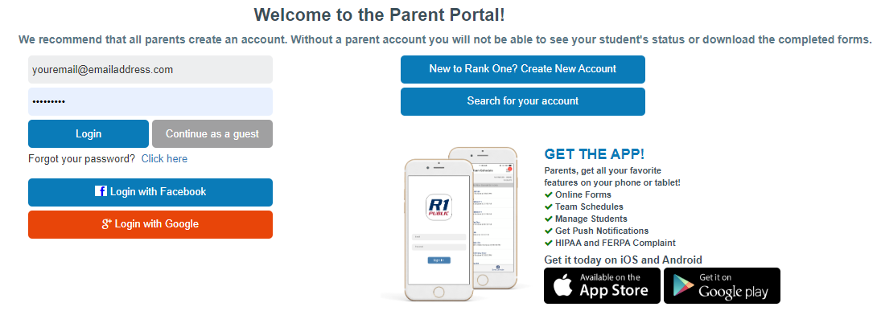
8. Parents must claim the student based on legal last name and school ID number.
Ex. Here is the button to add a new student as well as what it looks like to claim a kid.
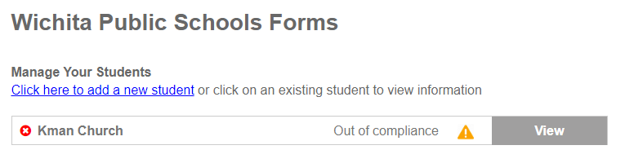
9. By clicking on the students name you will get a list of all forms needed.
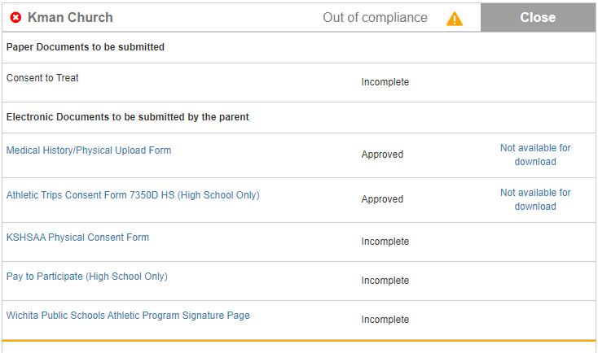

10. Click each link and both parent and student must electronically sign each form.
a. Each page of the physical (1-4) must be filled out, and electronically uploaded using the upload by selecting a Picture and taking a picture of each page in the correct section.
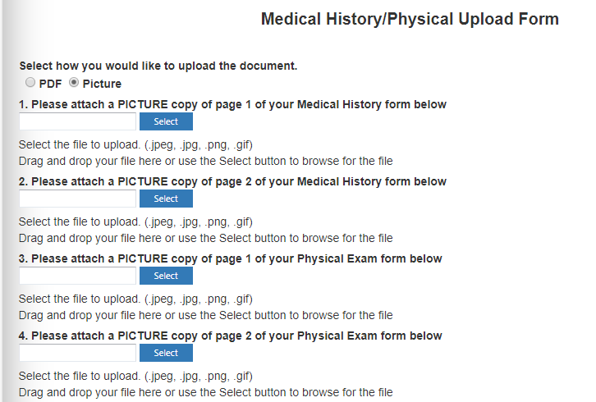
11. Go through each form from #9. And fill them out.
12. One you are done wait for final approval which will be done by the Athletic Director.

